Leech Lake Band of Ojibwe  
Food Distribution Center Expansion

design/BID/build - RFP #001-2025

**Soliciting Party**

**Client**: Leech Lake Band of Ojibwe

**Address**: 190 Sailstar Drive NW, Cass Lake, MN, 56633

**Phone**: (218) 335-8200

**Construction Site**

**Address**: 16051 65th Ave NW, Cass Lake, MN 56633

**Contact:** Gavin Herrera, Planner

**Phone**: 218-335-8365

**Email:** Gavin.Herrera@llojibwe.net

Contents

RFP Overview and Purpose 2

1. General Requirements 2

2. Selection Process 3

3. Project Scope 4

4. Required Proposal Content 4

5. Scoring breakdown 5

6. Suggested timeline (guide only, times/dates are subject to change) 5

7. Appendix 5

[**Figure 1 Current Facility** 6](https://llbo-my.sharepoint.com/personal/bryan_mccoy_llojibwe_net/Documents/Documents/Grant_and_Projects/ICDBG%20FoodShelf/RFP%20Items/Food%20Center%20RFP.docx#_Toc169612229)

[**Figure 2 Comparison of Current To New Facility** 7](https://llbo-my.sharepoint.com/personal/bryan_mccoy_llojibwe_net/Documents/Documents/Grant_and_Projects/ICDBG%20FoodShelf/RFP%20Items/Food%20Center%20RFP.docx#_Toc169612230)

[**Figure 3 Proposed Remodel and Expansion** 8](https://llbo-my.sharepoint.com/personal/bryan_mccoy_llojibwe_net/Documents/Documents/Grant_and_Projects/ICDBG%20FoodShelf/RFP%20Items/Food%20Center%20RFP.docx#_Toc169612231)

[**Figure 4 Site Location** 9](https://llbo-my.sharepoint.com/personal/bryan_mccoy_llojibwe_net/Documents/Documents/Grant_and_Projects/ICDBG%20FoodShelf/RFP%20Items/Food%20Center%20RFP.docx#_Toc169612232)

# RFP Overview and Purpose

The Leech Lake Band of Ojibwe (LLBO), referred to as "The Band," is seeking a licensed architectural firm or general contractor to handle the development of construction documents, solicitation of contractors, and management of construction services using the Design-Build (DB) project delivery method. This project involves the renovation and expansion of the Leech Lake Food Distribution Center located at 16051 65th Ave NW, Cass Lake, MN 56633. The current facility is 8,500 square feet, and the proposed remodel will expand it to 20,000 square feet.

## General Requirements

|  |
| --- |
| 1. LLBO is seeking a licensed architectural firm or general contractor to lead a DB project informed by existing schematic design (see appendix v) to be brought up to Minnesota State code with the goal enhancing access to healthy foods, where the proposals will be accepted or denied by Tribal Council 2. All works will need to comply to Minnesota State building code 3. Bidders must have general liability insurance, minimum $1,000,000.00 of coverage. 4. OSHA safety guidelines will need to be adhered to 5. Must comply with Tribal Employment Rights Ordinance (TERO), including, but not limited to:   • Minimum numerical hiring goal-Means the minimum percentage of Indian employees out of all persons employed by a contractor. One hundred percent (100%) of the labor force, classified as skilled or unskilled laborers on a project, shall be from the T.E.R.O. office. Sixty percent (60%) of the skilled labor force, classified as "any skilled tradesman" on a project, shall be from the T.E.R.O. office.  • For each contract of $5,000.00 or more, a fee of 3% of the total contract shall be assessed.  •Every covered entity, contractor, and subcontractor intending to engage in a consensual business activity with the tribe on the Reservation must, prior to the time it commences work on the Reservation, submit a contracting and subcontracting compliance plan to the Office. No covered entity, contractor, or subcontractor may commence work on the Reservation until it has met with the TERO Director or their delegate and has developed an acceptable plan for meeting its obligations under these regulations.   1. Contractor has not been debarred, suspended, or declared ineligible from doing business with any Tribal, Federal, State, or Local governments. 2. Awardee will be required to sign a hold harmless agreement and provide a W9. 3. Project is tax exempt 4. Leech Lake Band of Ojibwe is a federally recognized Indian tribe, retaining aspects of sovereignty including sovereign immunity. If the proposer is requesting a waiver of sovereign immunity, then Leech Lake requires that dispute resolution be limited to mediation and/or arbitration, including an express waiver of any right to a jury trial. |

## Selection Process

|  |
| --- |
| 1. The architectural firm or general contractor will be selected through a competitive bidding process based on the best value, Contractor’s ability to complete the project scope, the selection criteria identified in this RFP, and determined to be in the best interest of the Band. Five Copies of your proposals shall be submitted to:   Darold Madigan, Purchasing Director  190 Sailstar Drive NW  Cass Lake, MN, 56633  (218) 308-1971  darold.madigan@llojibwe.net  Questions Related to the RFP or the project can be addressed to:  Gavin Herrera, Planner  190 Sailstar Drive NW  Cass Lake, MN, 56633  (218) 335-8365  Gavin.Herrera@llojibwe.net   1. Provide letter of intent to submit proposal. 2. The bidder must submit documentation that provides evidence that they are capable, have expertise, and experience to perform the works required described in the RFP. 3. Proposals submitted after **8/16/24 4:30 PM** will not be considered. 4. Selection Criteria    * Ownership group will submit their recommendation to LLBO Tribal Council for approval by quorum, as defined in the tribal by-laws    * Fee structure to be provided (percentage or flat fee)    * Past tribal work experience    * Availability to perform work    * Communication plan    * Provide overall cost estimate    * Timeline for project completion 5. All bids must be sealed. |

## Project Scope

|  |
| --- |
| 1. Assess the selected site location. 2. Develop detailed plans for the LLBO Food Distribution based on preliminary design work. 3. Implement the construction phase of the project, adhering to safety standards, quality workmanship, and strict adherence to the approved design plans. 4. Follow any State/Federal/Local procurement standards when selecting contractor(s). 5. Provide regular progress reports to the LLBO and keep Tribal council informed of any significant developments. 6. Ensure the completion of the project within the agreed-upon timeline and budget until project completion. 7. Total cost of project, including pre-construction cost are not to exceed $1,724.644 8. Site visits are encouraged but not required between the hours of 8-4:30, Monday through Friday. |

## Required Proposal Content

|  |
| --- |
| 1. **Contact Information:** Street, mailing address, telephone, and email address. 2. **Proposal Narrative:** A proposal narrative explaining the overall strategy to be taken toward completion of the project scope, how each phase will be completed, and any recommended changes in the phasing as presented in this RFP. 3. **Qualifications & Certifications:** Brief statement of qualifications together with appropriate supplemental information demonstrating qualifications; relevant licenses, relevant certifications/accreditations, workforce development, etc. Identify other key personnel/organizations who will help undertake the proposed project. 4. **Knowledge and Experience with Tribes:** cultural considerations, compliance with tribal regulations, experience working with tribal communities. 5. **Examples of Past projects:** Projects of similar scale. 6. **Budget & Timeline:** Present summary of total project cost, payment schedule, project phases, estimated start and end date 7. **References:** Provide a list of references and/or letters of recommendation. 8. **Fee Structure**: provide unit prices for materials and hourly rates for professional services and staff time. 9. **Form of Contract:** provide proposed form of contract. |

## Scoring breakdown

|  |  |  |  |  |  |  |  |  |  |  |  |  |  |  |  |  |
| --- | --- | --- | --- | --- | --- | --- | --- | --- | --- | --- | --- | --- | --- | --- | --- | --- |
| |  |  | | --- | --- | | **Criteria** | **Point Scale** | | Proposal Narrative | 25 | | Qualifications & Certifications | 20 | | Knowledge and experience with Tribal entities | 12 | | Examples of past projects | 13 | | Budget & Timeline | 15 | | References | 9 | | Native preference | 1 | |

## Suggested timeline (guide only, times/dates are subject to change)

|  |
| --- |
| 8/4/24 – RFP Issued  8/16/24 – Proposals Due (by 4:30 PM)  8/30/24 – Selected company notified |

The issuance of this RFP does not obligate Leech Lake Band of Ojibwe to award a contract or pay any costs incurred in the preparation of the proposal.

## Appendix

1. LLBO TERO site- <http://www.llojibwe.org/td/tero.html>
2. Tribal Employment Rights Ordinance link- <http://www.llojibwe.org/court/tcCodes/tc_title17_TERO.pdf>
3. Compliance plan link- <http://www.llojibwe.org/td/terodocs/TERO%20Compliance%20Plan.pdf>
4. Schematic of current layout
5. Schematic of proposed facility
6. Site location



**Figure 1 Current Facility**

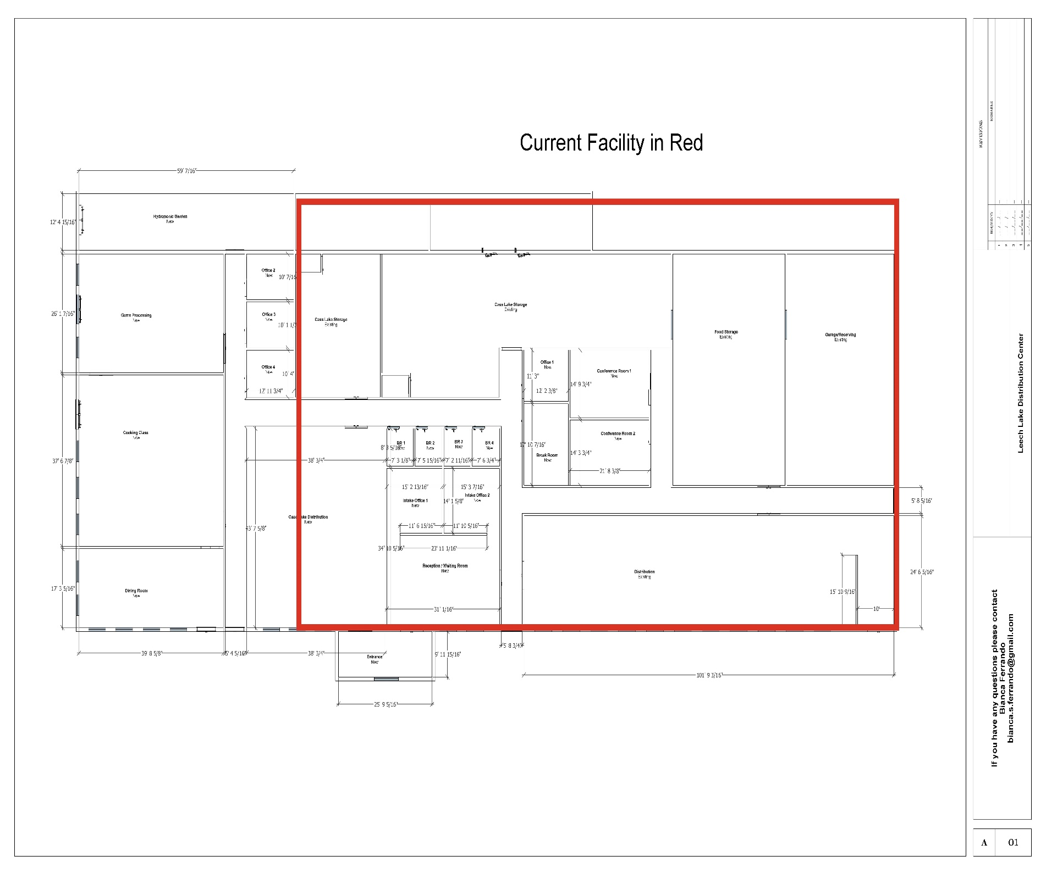

**Figure 2 Comparison of Current To New Facility**



**Figure 3 Proposed Remodel and Expansion**

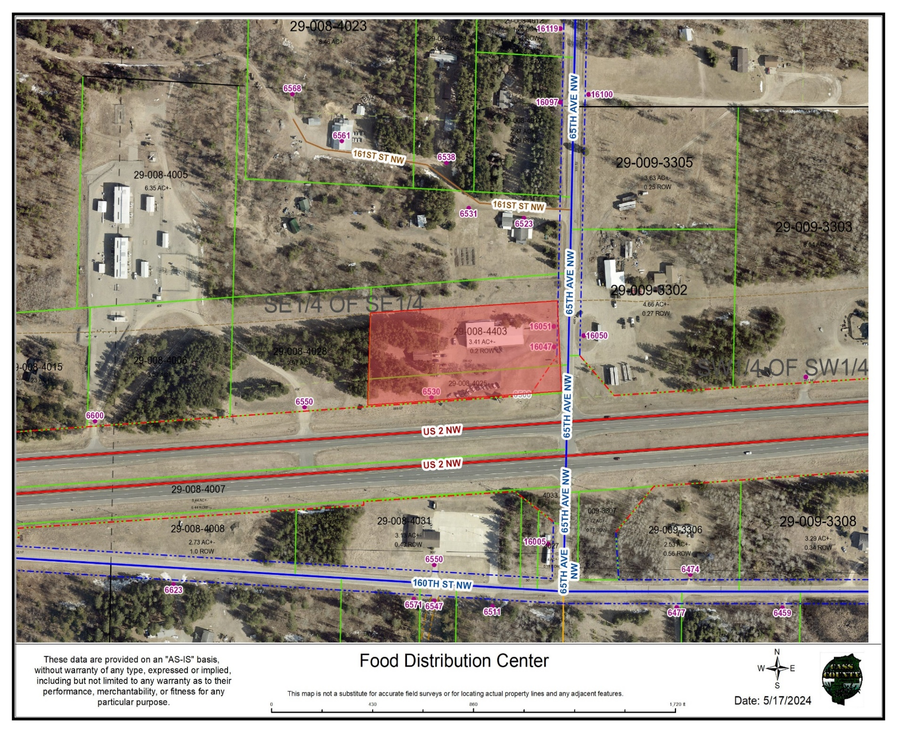

**Figure 4 Site Location**